**Optional tasks German AS/A-level 2025**

**Please keep a log of anything you do and bring it in September**

1. 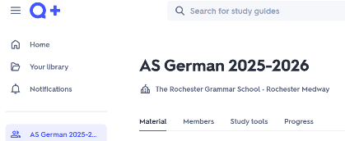**Vocabulary:**

* Set up a Quizlet account if you don’t have one
* Log in
* Join this class:

<https://quizlet.com/join/beE4t7jgF?i=1b15su&x=1bqt>

* Start with 1.1 and work your way through in order

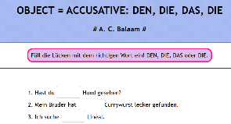

1. **Grammar**

* [languages online](https://www.languagesonline.org.uk/Hotpotatoes/germanindex.html#Grammar)
* Pick some topics with which you are not familiar and practise them.
* Start with the cases, if you are not confident with accusative and dative.

1. **Films**

* Watch the film we will be studying:
* **Good bye, Lenin!**
* Other films to watch:
* **Das Leben der Anderen (The Lives of Others)**
* **Lola rennt (Run, Lola, Run)**
* **Der Untergang (Downfall)**
* **Almanya, Willkommen in Deutschland (Almanya, welcome to Germany)**
* **Die Welle (The wave)**

1. **Reading**

* Read the book we will study in Year 13
* **Der Besuch der alten Dame**
* Other books to read:
* **Russendisko**
* **Der Vorleser**
* **Tintenherz (Inkheart)**
* **Die unendliche Geschichte (The never ending story)**

1. **News**

Watch slowly spoken simplified news

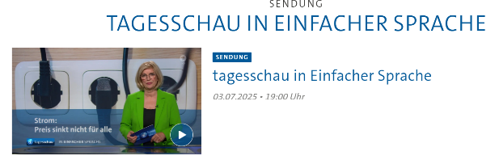 [tagesschau in Einfacher Sprache | tagesschau.de](https://www.tagesschau.de/multimedia/sendung/tagesschau_in_einfacher_sprache)

1. **Listen to a podcast**

[www.slowgerman.com](http://www.slowgerman.com)

