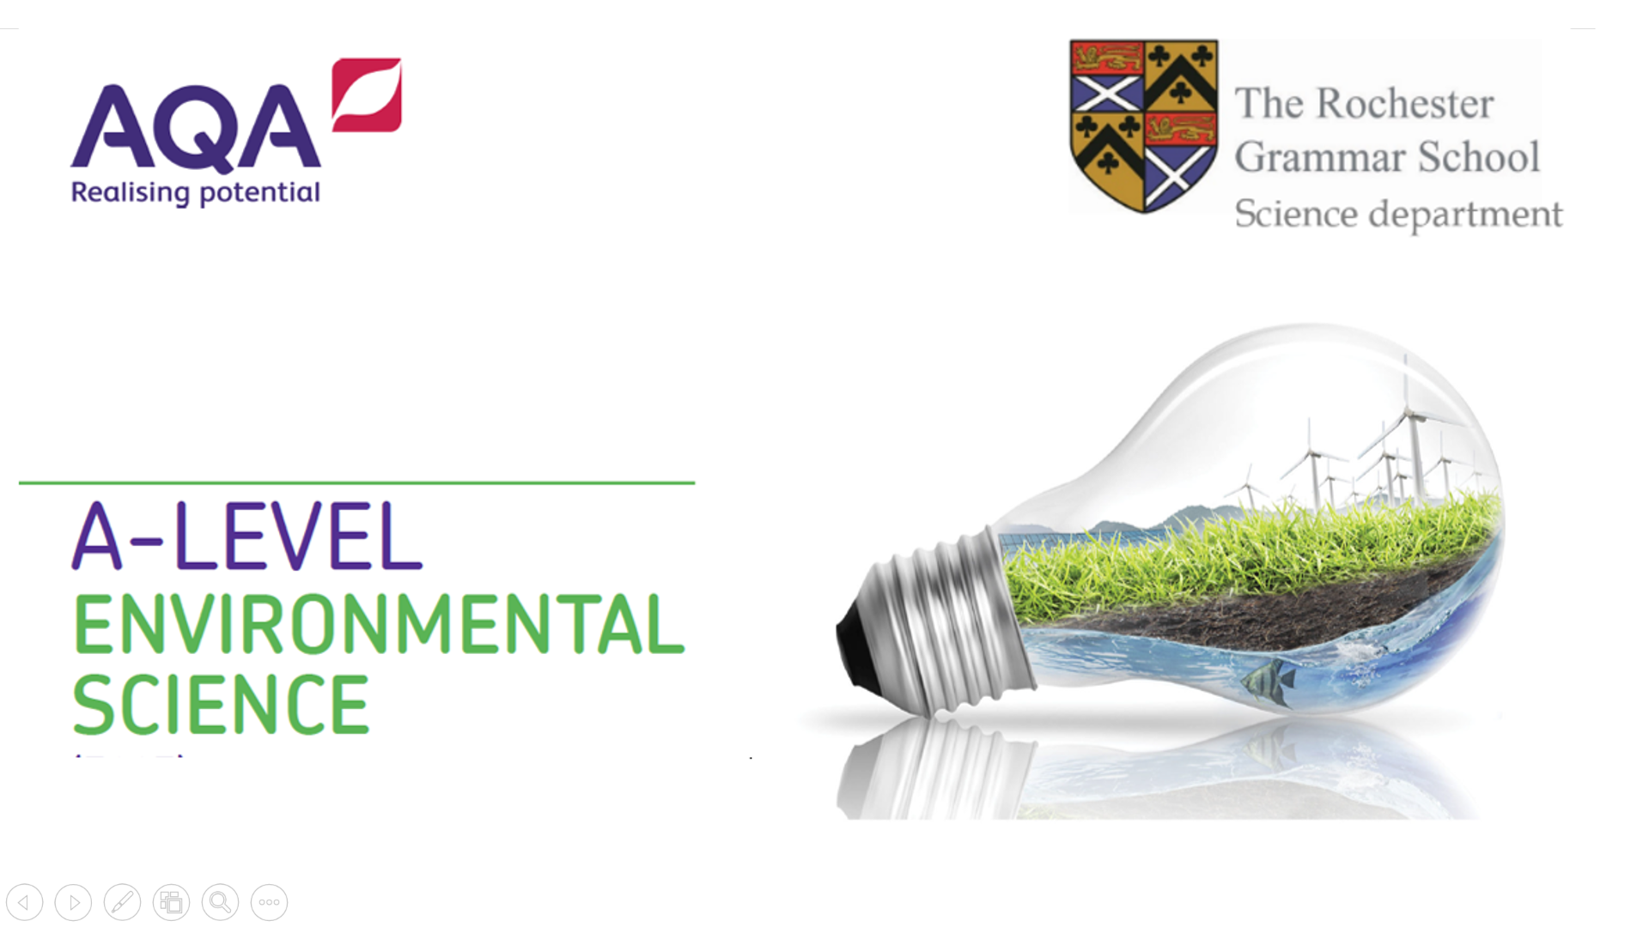

**Links for research:**

[General information](http://www.countrysideinfo.co.uk/biodvy.htm)

[Zoological Society of London – field Conservation](https://www.zsl.org/conservation)

[New species](http://www.abc.net.au/science/news/stories/s143723.htm)

[Introduced species in the UK](http://www.introduced-species.co.uk/)

[World Conservation Union - IUCN](http://www.iucn.org/)

[WWF threatened species](http://www.worldwildlife.org/endangered/)

[Ramsar sites](http://www.jncc.gov.uk/page-161)

[UK designated areas](http://www.naturalengland.org.uk/conservation/designated-areas/default.htm)

[Millennium seedbank](http://www.kew.org/wakehurst/attractions/millennium-seed-bank)

[Eradication of invasive species](http://diise.islandconservation.org/)