**Drama & Theatre Optional Summer Tasks**

**Set text reading**

*You can find copies of our set texts for the written paper here:*

1. That Face by Polly Stenham

<https://oceanofpdf.com/authors/polly-stenham/pdf-that-face-download/>

1. Lysistrata by Aristophanes (Alan H. Sommerstein)

<https://stuff.mit.edu/afs/athena/course/21/21h.301/www/local/aristophanes.lysistrata.pdf>

**Additional tasks**

*Choose a 10-minute extract (roughly 3-4 pages) from a play text of your choice NOT a musical- this must be a style of script/character that you would love to perform and is suitable for A-level study-this can be a duologue, have multiple characters OR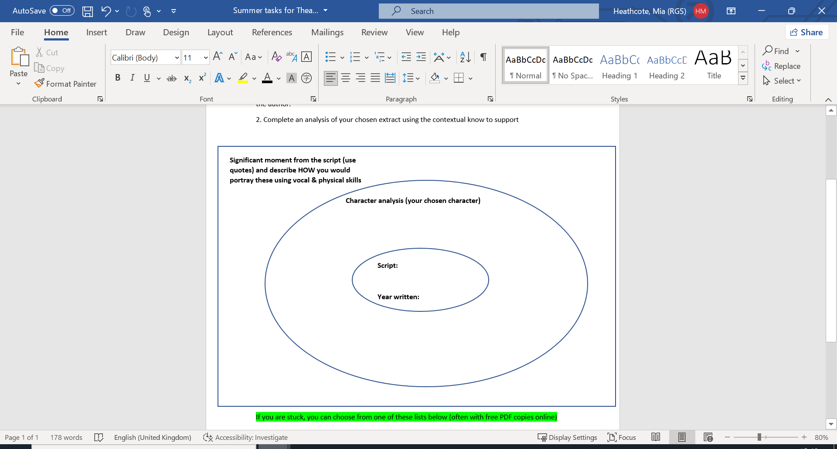 a monologue.*

*Complete the following tasks in reference to the chosen extract*

1. Complete some research to support with the contextual understanding of the play text (1 page max), focus on the social, historical & political context of the time it was written in alongside the author.

Complete an analysis of your chosen extract using the contextual knowledge to support your choices

If you are stuck, you can choose from one of these lists below (often with free PDF copies online)

1. Tennessee Williams - A Streetcar Named Desire

2. Mark Ravenhill - Over There

3. Henrik Ibsen – A Doll’s House

4. Arthur Miller – The Crucible

5. Saved- Edward Bond

OR access some others here <https://www.playscripts.com/sample/5671>